***Screenshots of E-Circuits of Half-Wave Rectifiers.***

*1. without Filter.*

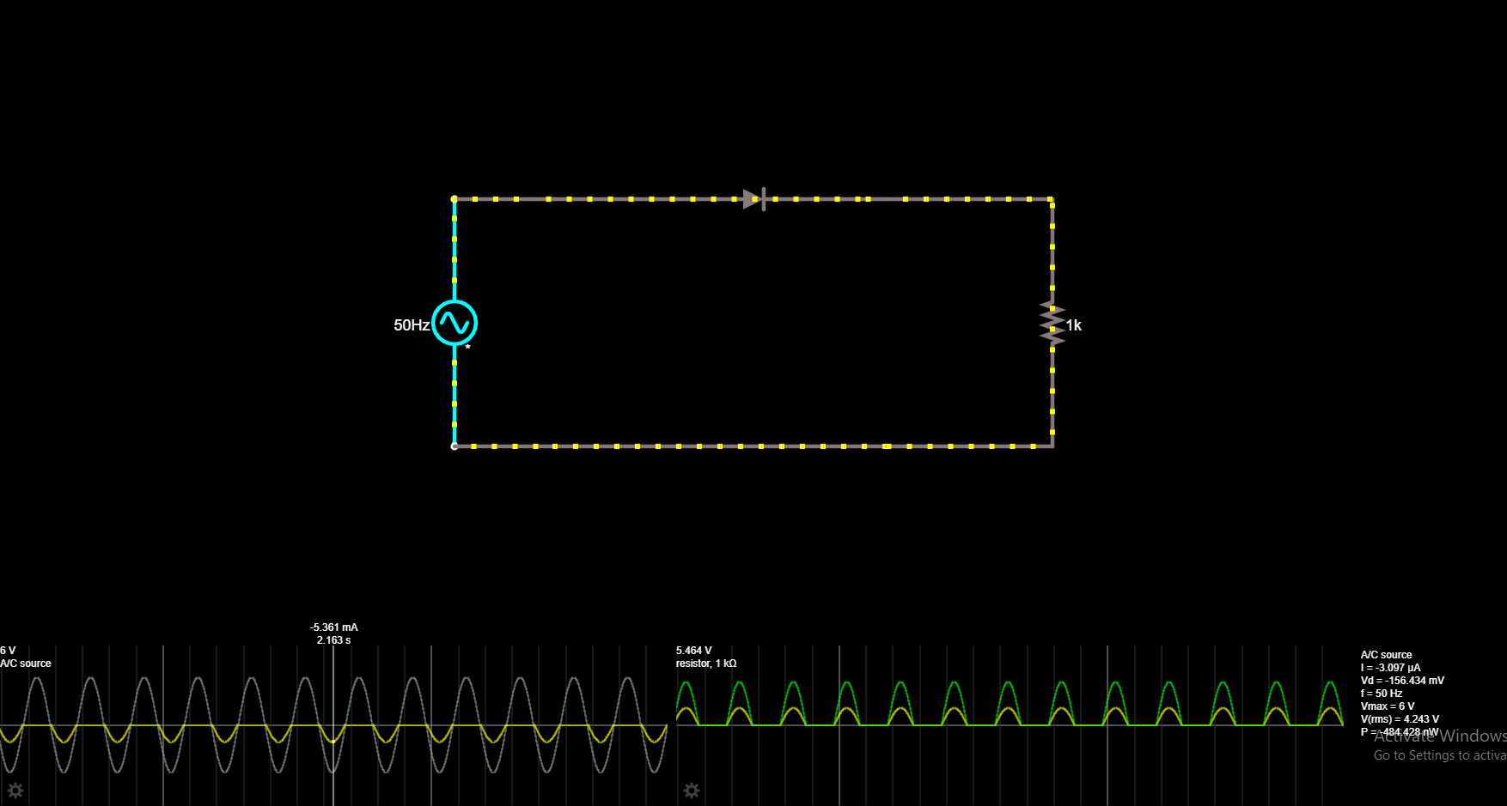

*2. with Filter.*

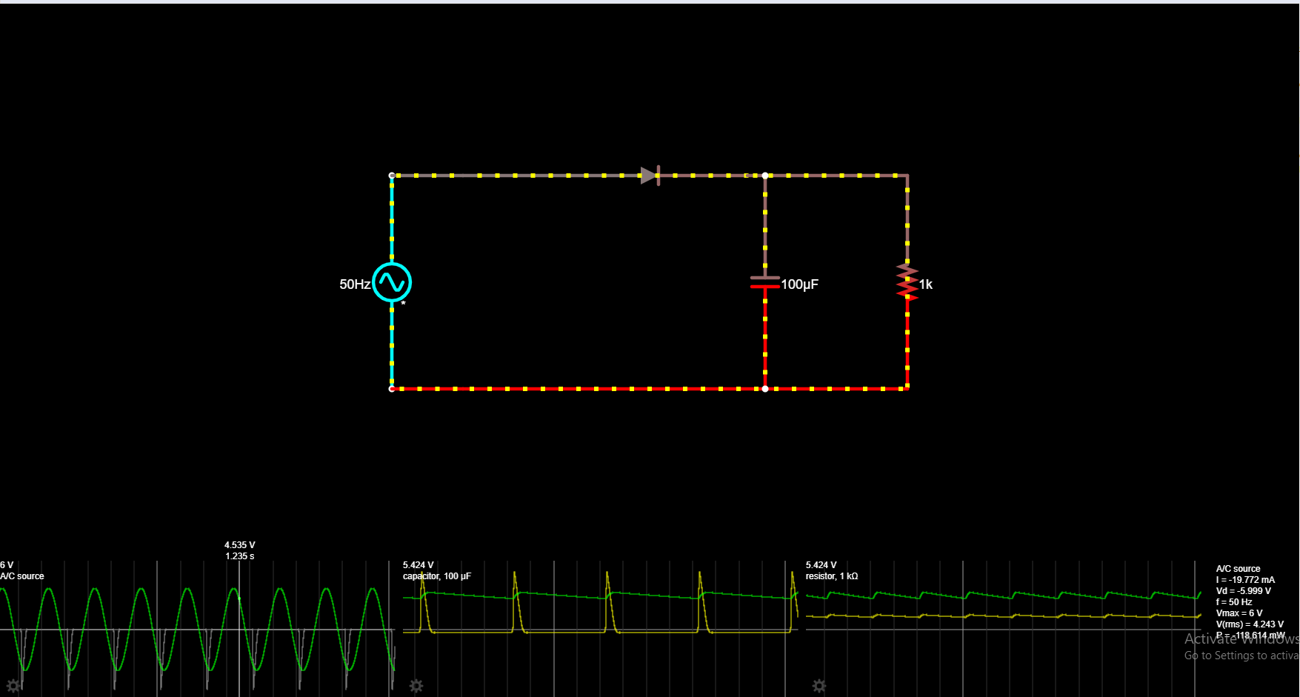

***Screenshots of E-Circuits of Full-Wave Rectifiers.***

*1. without Filter.*

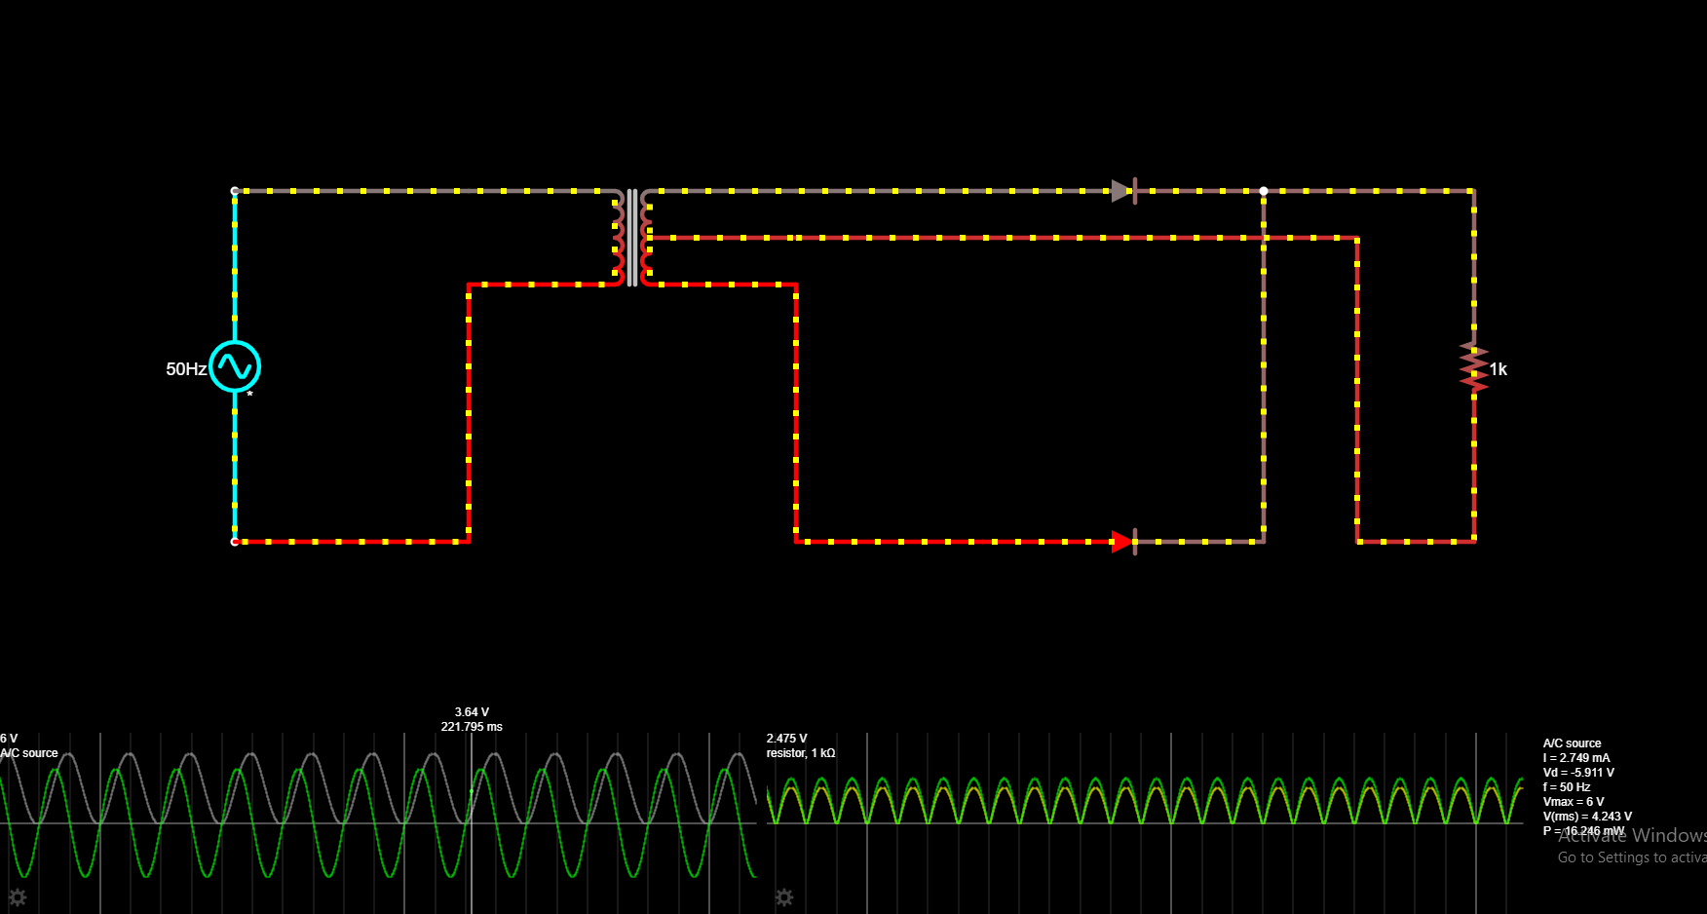

*2. with Filter.*

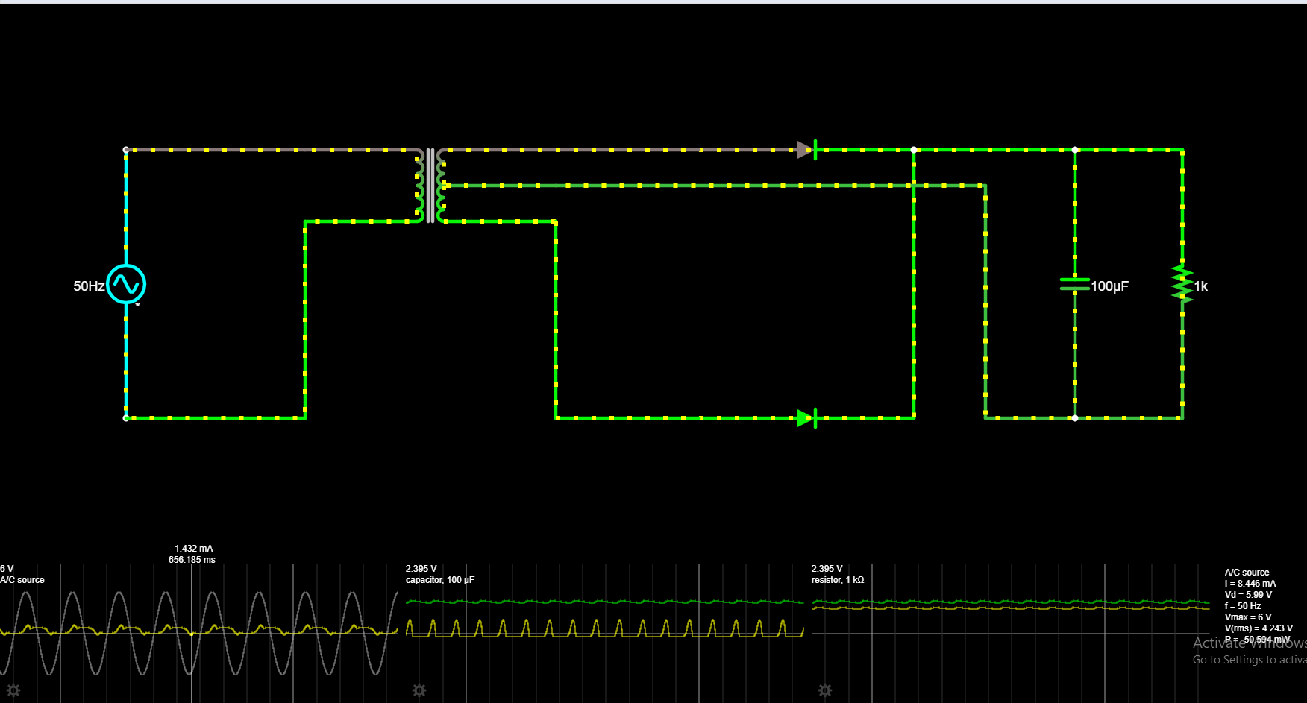

***Screenshots of E-Circuits of Clippers.***

*1. Unbiased (+ve).*

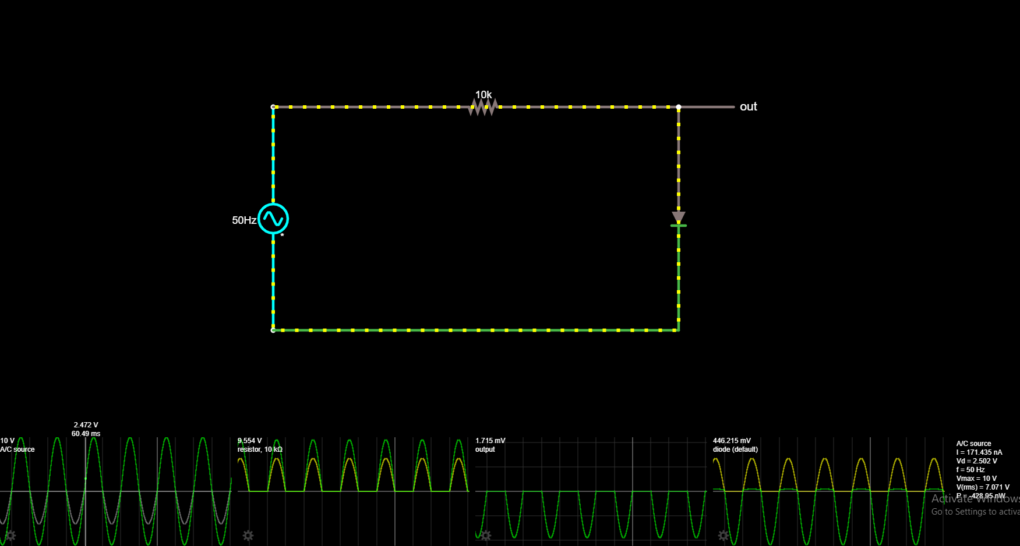

*2. Biased (+ve).*

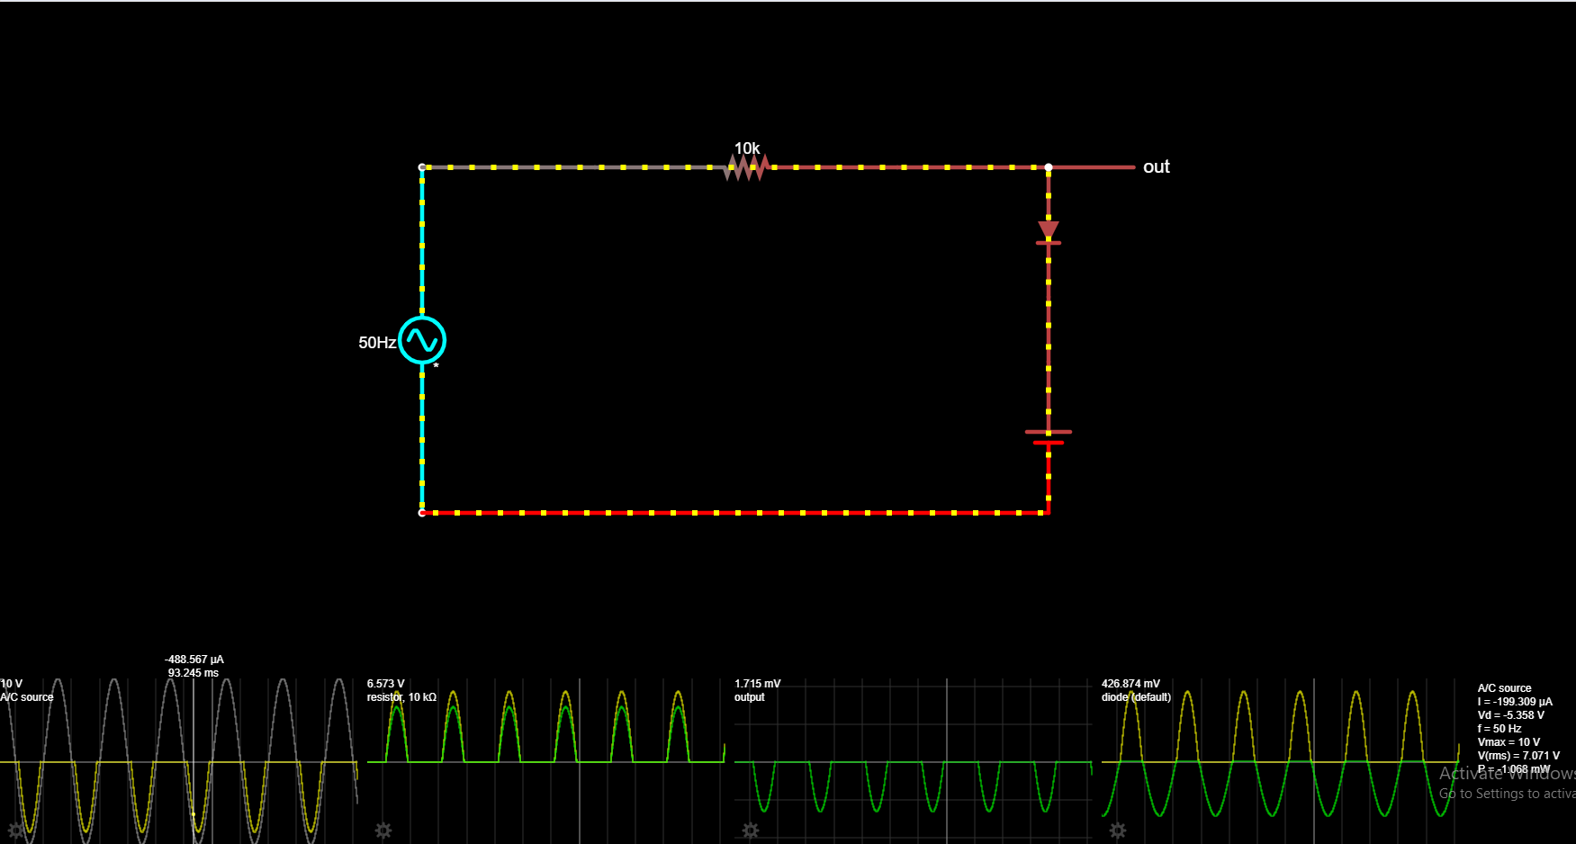

*3. Unbiased (-ve).*

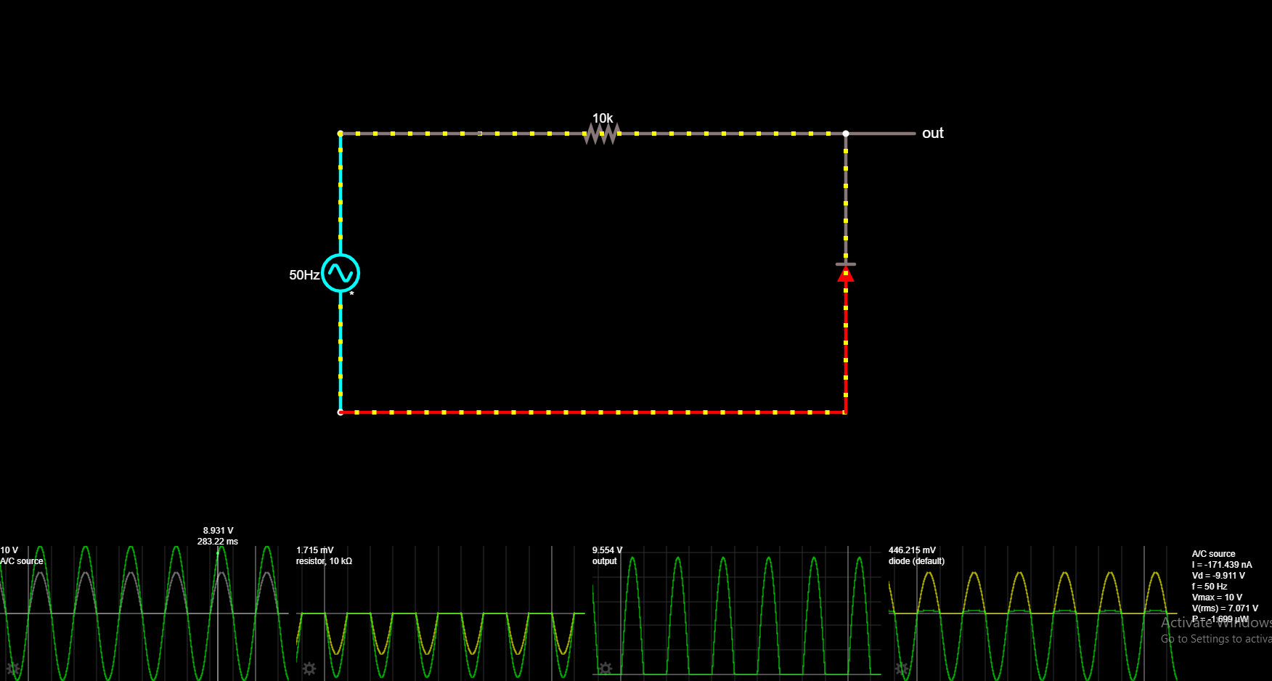

*4. Biased (-ve).*

